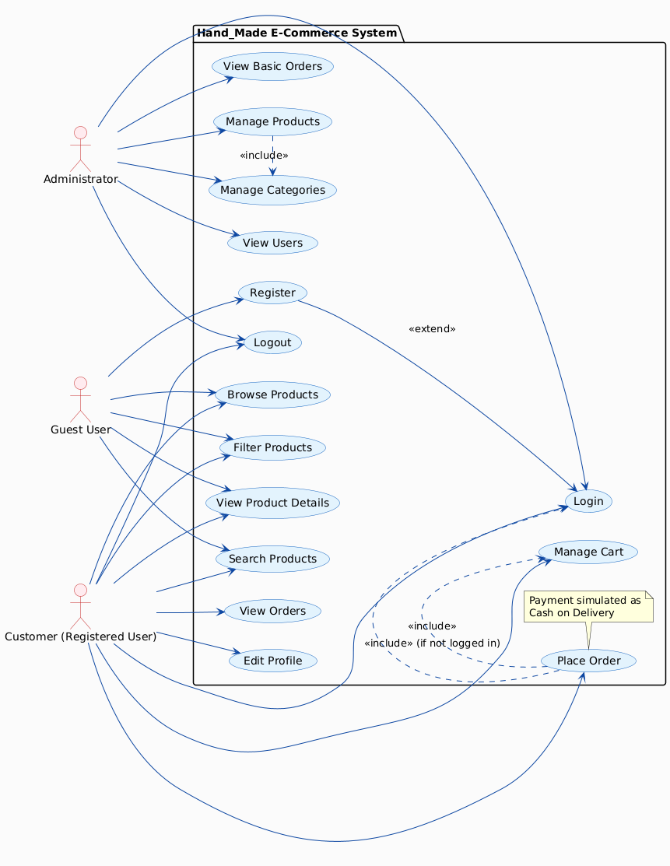

Roles of Each Actor :-
- Guest User:
  - Can browse and filter products, but must register/login to place an order or see order history.
  - Role: Unauthenticated visitor who explores the site without committing to purchases. Requires only basic web browsing knowledge.
- Customer (Registered User):
  - Can browse products, manage cart, and place orders.
  - Can view and edit profile, view previous orders.
  - Role: Primary end-user who shops for handmade products like keychains, frames, etc. Requires only basic knowledge of web browsing.
- Administrator:
  - Has elevated privileges to manage catalog, categories, and basic orders.
  - Can view registered users and basic order status.
  - Role: System manager (e.g., project team member or faculty). Expected to have moderate technical skills and familiarity with Django admin for CRUD operations.

Activity Diagram: Activity diagram is a special kind of a state chart diagram that shows the flow from activity to activity within a system. These diagrams address dynamic view of a system. Activity Diagram displays a special state diagram where most of the states are action states and most of the transitions are triggered by completion of the actions in the source states.

